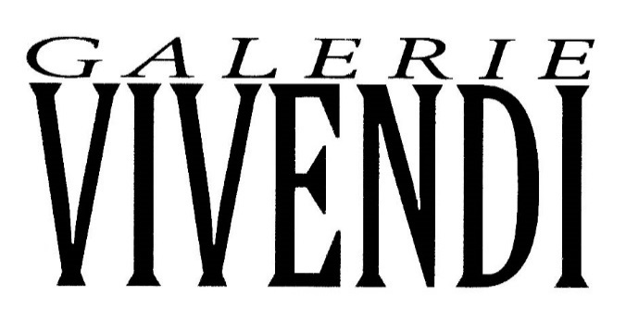
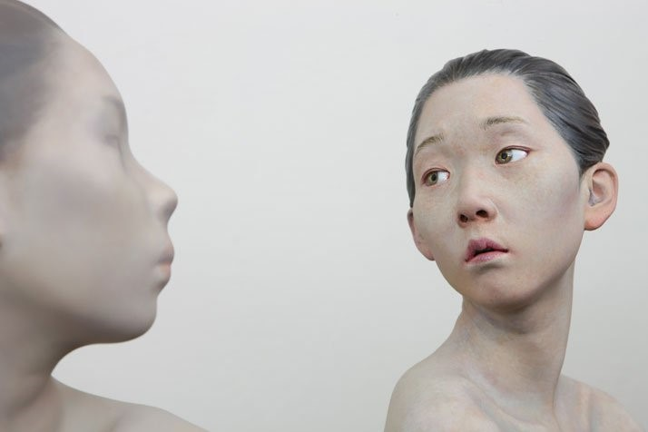
Choi Xooang, Reflection, 2012, resin, 52 x 82 cm

Celebrating its 11th Anniversary, SCOPE Art Show secures its future in Basel with a long term investment in the city's rich culture. SCOPE | Haus will host creative events focused on complementing Basel's blooming contemporary art, design, music, and architecture scene.
A brief 5 minute walk from Art Basel (Messeplatz), SCOPE Basel’s well-appointed venue offers collectors the most convenient and ideal view of the contemporary art world available nowhere else. SCOPE Basel will welcome 70 International Exhibitors from 52 cities and 27 countries.
Vivendi gallery will be represented in Basel and its artists will be exhibited, among them the artworks of Beyel, Donadini, Corda, Son Seock, Zhuang Hong Yi, Stiller, Dario, Hayat, Soumi, Bombardieri, Bastiani, Craig Alan, Adam and Choi Xooang.

